Haan

Kip

[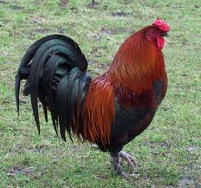](http://www.google.com/imgres?hl=en&authuser=0&biw=1185&bih=596&tbm=isch&tbnid=vGpwIfL1D6MwHM:&imgrefurl=http://pietschellekens.blogspot.com/2010/12/56-de-kersthaan-van-opa_22.html&docid=lXe6K_xwPSPvDM&imgurl=http://1.bp.blogspot.com/_0zrfDMqCYSg/TRJYcbKew3I/AAAAAAAAAUQ/ZToQzxm891Q/s1600/haan%2B2.jpg&w=1200&h=1124&ei=TPEtUY2-NIPN0QWDiYDgAw&zoom=1&ved=1t:3588,r:4,s:0,i:108&iact=rc&dur=363&sig=110133473144911172894&page=1&tbnh=185&tbnw=199&start=0&ndsp=12&tx=122.148193359375&ty=100.59262084960937)

**Kukeleku Kukeleku**

[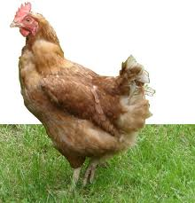](http://www.google.com/imgres?num=10&hl=en&authuser=0&biw=1185&bih=596&tbm=isch&tbnid=CMM17B9luteZnM:&imgrefurl=http://www.sparnijlen.be/Webshop.asp?cat=44049&scat=132877&docid=uuWLN-2ik4lO-M&imgurl=http://www.sparnijlen.be/Medias/Webshop1/scat_132877_a.jpg&w=1299&h=1349&ei=9vAtUYS2GonG0QWlwYGwDw&zoom=1&ved=1t:3588,r:28,s:0,i:245&iact=rc&dur=692&sig=110133473144911172894&page=2&tbnh=180&tbnw=173&start=12&ndsp=18&tx=86.3333740234375&ty=126.14816284179687)

**Toktoktok tok tok**

**kakelen**

**kraaien**