|  |
| --- |
| [https://encrypted-tbn1.gstatic.com/images?q=tbn:ANd9GcTll1FLvAgbhfIO93THm1tcHaJ8Gir8uhC-mu_PvV2wnN4bstYviw](http://www.google.nl/imgres?um=1&hl=nl&rlz=1T4SVEE_nl___NL412&biw=1920&bih=817&tbm=isch&tbnid=aXi1vr2LqnLKPM:&imgrefurl=http://mariel1.wordpress.com/2012/04/03/gratis-wallpaper-voor-pasen/twee-eieren2/&docid=9dYsHgUIClvXmM&imgurl=https://mariel1.files.wordpress.com/2012/04/twee-eieren2.jpg&w=1000&h=750&ei=lrd1UOnWLfTJ0AWlkYHoCA&zoom=1&iact=hc&vpx=1614&vpy=382&dur=2153&hovh=194&hovw=259&tx=153&ty=102&sig=101416969009224564263&page=1&tbnh=116&tbnw=151&start=0&ndsp=57&ved=1t:429,r:34,s:0,i:176)  **2**  **het paar** |

|  |
| --- |
|  |

|  |
| --- |
| **144** |

[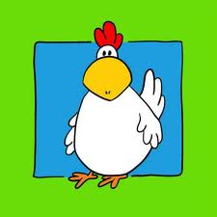](http://www.google.nl/imgres?um=1&hl=nl&rlz=1T4SVEE_nl___NL412&biw=1920&bih=817&tbm=isch&tbnid=P8A7rvYWauaZnM:&imgrefurl=http://www.vrijspreker.nl/wp/2012/08/plofkip-geweerd-zonder-overheid/kip/&docid=NCPY2QYqa1iAiM&imgurl=http://www.vrijspreker.nl/wp/wp-content/media/2012/08/kip.jpg&w=485&h=485&ei=pLp1UOeoIuaZ0QWWq4BY&zoom=1&iact=hc&vpx=1048&vpy=144&dur=1482&hovh=225&hovw=225&tx=118&ty=130&sig=101416969009224564263&page=1&tbnh=87&tbnw=100&start=0&ndsp=68&ved=1t:429,r:8,s:0,i:158)

**het gros**

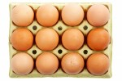

**het dozijn**



**12**