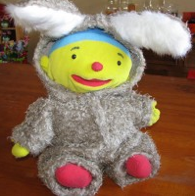[](http://www.google.nl/imgres?imgurl=http://basbakkenes.com/korenbloem/wp-content/uploads/2012/01/paaseieren.jpg&imgrefurl=http://basbakkenes.com/korenbloem/kalender/paaseieren-zoeken&h=300&w=300&sz=97&tbnid=iDzK-2wa92DYvM:&tbnh=90&tbnw=90&prev=/search%3Fq%3Dpaaseieren%26tbm%3Disch%26tbo%3Du&zoom=1&q=paaseieren&docid=WJ5wFLkYSP3YbM&hl=nl&sa=X&ei=nPlET7CgO4fF8gPmqsmxBA&ved=0CHwQ9QEwAg&dur=3217)

**Pasen**

**Paashaas**

**Paaseieren**