

**wandelen**

**schrijden**

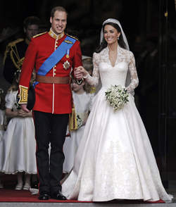

**flaneren**

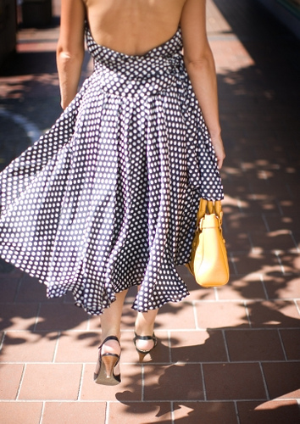

**kuieren**

[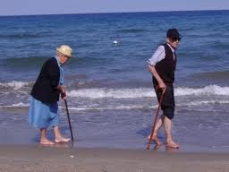](http://www.google.nl/imgres?q=kuieren&hl=nl&gbv=2&biw=1024&bih=571&tbm=isch&tbnid=Fk4zw-tMwkANgM:&imgrefurl=http://hubenyvonne.punt.nl/?id=527517&r=1&tbl_archief=1&&docid=Ggk7YM88QbGu5M&imgurl=http://i441.photobucket.com/albums/qq131/Kahlidu/weblog/P5040424.jpg&w=320&h=240&ei=rJS7T7znBsm90QW9oNjSBw&zoom=1&iact=hc&vpx=284&vpy=140&dur=141&hovh=192&hovw=256&tx=146&ty=111&sig=112043562182564383279&page=1&tbnh=117&tbnw=179&start=0&ndsp=15&ved=1t:429,r:1,s:0,i:71)

**struinen**

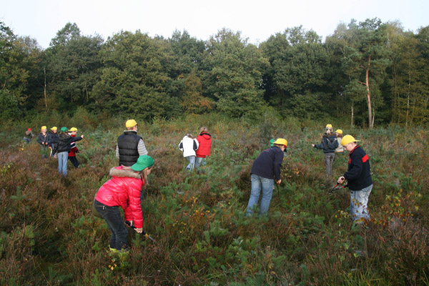

**stiefelen**

