[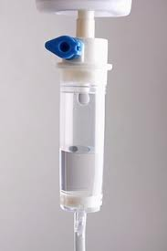](http://www.google.com/imgres?hl=en&authuser=0&biw=1185&bih=596&tbm=isch&tbnid=_6oFo9PX4QzJ0M:&imgrefurl=http://medischcontact.artsennet.nl/artikel/77420/deelname-doodstraf-anesthesioloog-ongewenst.htm&docid=eGeGqDxytDh3hM&imgurl=http://medischcontact.artsennet.nl/upload/4a8c48c6-ebb8-45c3-bb0b-bd34395c22d6_infuus.250.jpg&w=250&h=374&ei=v44vUdHtAo6r0AWRroCoBg&zoom=1&ved=1t:3588,r:60,s:0,i:269&iact=rc&dur=773&sig=110133473144911172894&page=4&tbnh=181&tbnw=113&start=58&ndsp=25&tx=42.25927734375&ty=118.0740966796875)[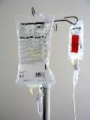](http://www.google.com/imgres?hl=en&authuser=0&biw=1185&bih=596&tbm=isch&tbnid=XzhcEIfn-bZ8eM:&imgrefurl=http://mensverbetering.wordpress.com/tag/infuus/&docid=QzpCuERMYdUlGM&imgurl=http://mensverbetering.files.wordpress.com/2012/12/infuuszakje150.jpg?w=584&w=150&h=200&ei=v44vUdHtAo6r0AWRroCoBg&zoom=1&ved=1t:3588,r:51,s:0,i:242&iact=rc&dur=350&sig=110133473144911172894&page=3&tbnh=160&tbnw=120&start=40&ndsp=18&tx=56.148193359375&ty=80.8148193359375)

**De Druppelaar**

[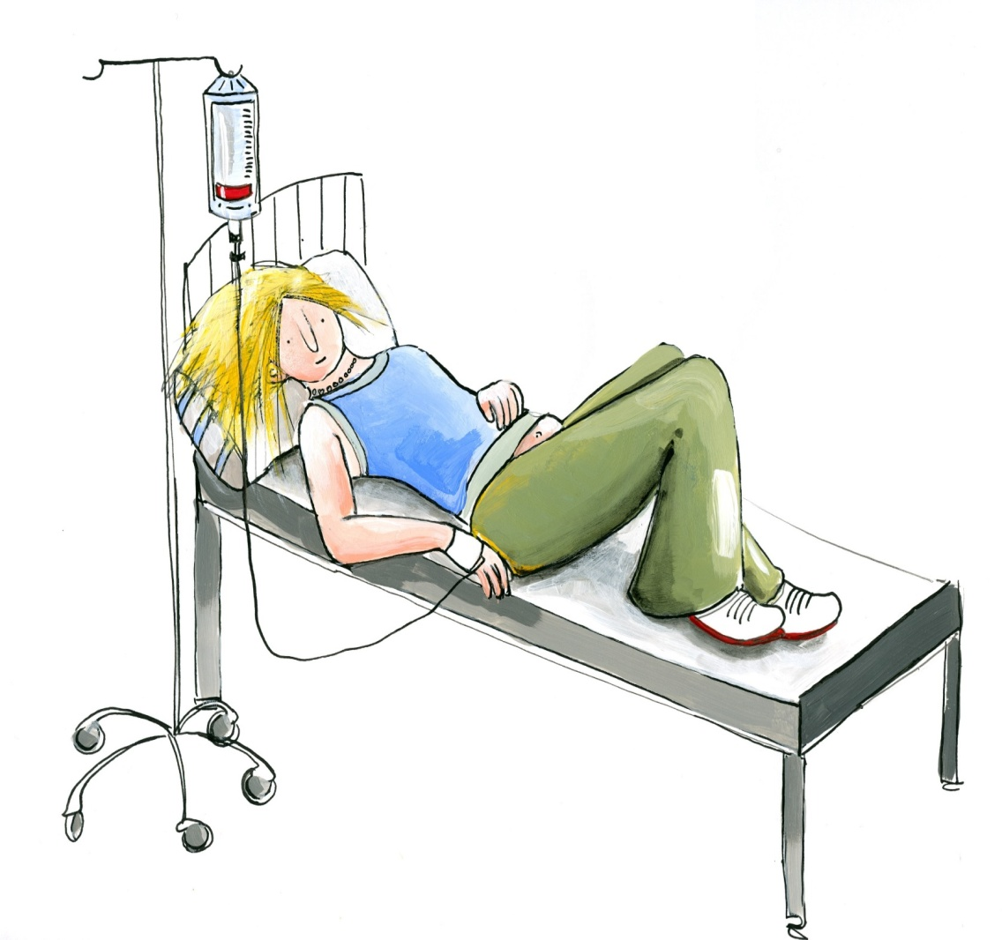](http://www.google.com/url?sa=i&rct=j&q=&esrc=s&frm=1&source=images&cd=&cad=rja&docid=KeCP_xl1Douw4M&tbnid=P0rz7aR16DGB4M:&ved=0CAUQjRw&url=http://www.mskidsweb.nl/display_item_print.php?ID=2206&table=item&menu_id=477&description1=MS%20X-TRA&description2=medicijnen&menu_id=477&expand=&symbol=&ei=P48vUYejK4-U0QWTy4DoBg&bvm=bv.43148975,d.d2k&psig=AFQjCNF88U4CsH8tXEKposItXNA00Z3bhQ&ust=1362157631473872)[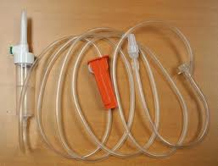](http://www.google.com/imgres?hl=en&authuser=0&biw=1185&bih=596&tbm=isch&tbnid=hF13S2V2jdcatM:&imgrefurl=http://www.medishop.be/medishop/spuiten-naalden-c-45.html&docid=iA_dYwqIZwo57M&imgurl=http://www.medishop.be/medishop/images/Perfusie49200.jpg&w=595&h=454&ei=v44vUdHtAo6r0AWRroCoBg&zoom=1&ved=1t:3588,r:81,s:0,i:332&iact=rc&dur=770&sig=110133473144911172894&page=4&tbnh=161&tbnw=222&start=58&ndsp=25&tx=76.9630126953125&ty=95.51852416992187)

**De vloeistof, het plasma**

**De infuusslang**

**Het infuus**