|  |
| --- |
| **Ontstaan** |

|  |
| --- |
|  |

|  |
| --- |
|  |

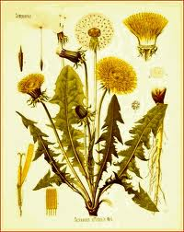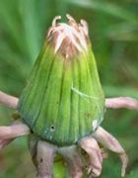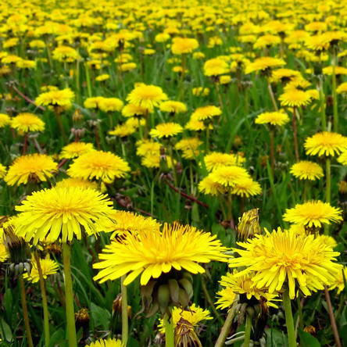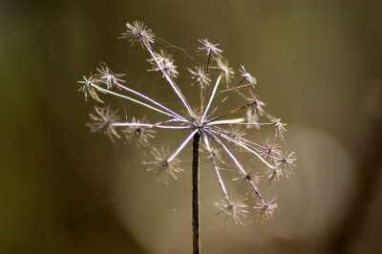

**Vergaan**

**Bestaan**