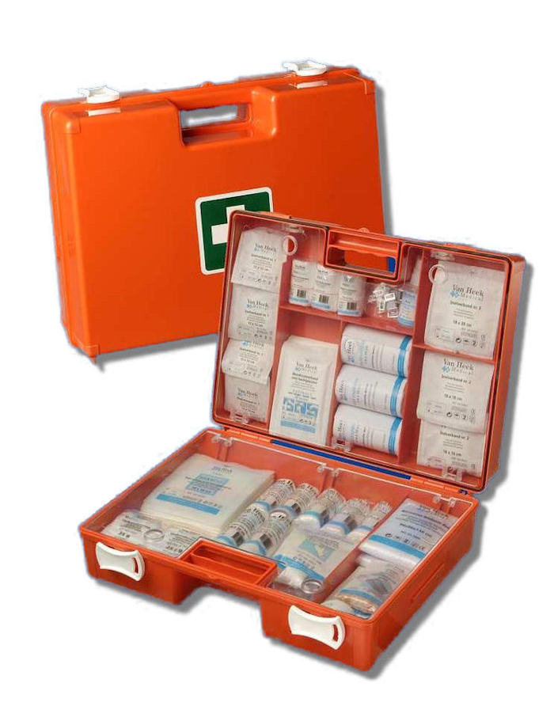**[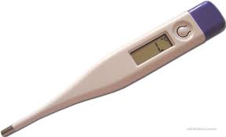](http://www.google.nl/imgres?q=thermometer&start=237&um=1&hl=nl&sa=N&rlz=1W1ACAW_nlNL316&biw=1280&bih=601&addh=36&tbm=isch&tbnid=8cOKI_-cH1SaKM:&imgrefurl=http://www.okokchina.com/product/Medicine-Health-Environment/Medical-Surgical-Instruments/Thermometers/index_3.htm&docid=neuay7oFyYV1oM&imgurl=http://www.okokchina.com/Files/uppic36/DIGITAL%252520THERMOMETER738.jpg&w=1151&h=700&ei=6U2FT_HYAsmS0QXIyJHPBw&zoom=1&iact=hc&vpx=670&vpy=328&dur=2893&hovh=175&hovw=288&tx=136&ty=121&sig=100960514420928106436&page=9&tbnh=95&tbnw=156&ndsp=28&ved=1t:429,r:11,s:237,i:156)**

De thermometer

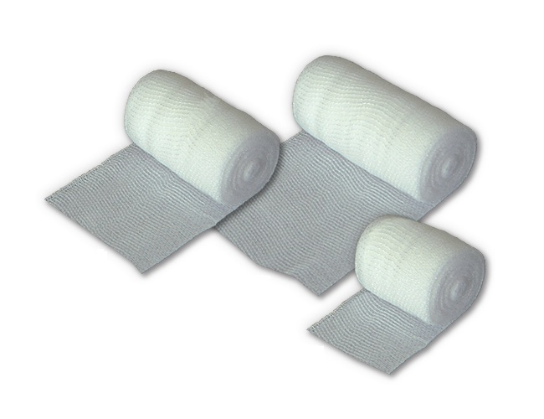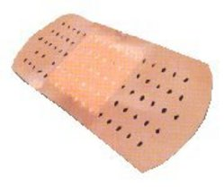

De verbanddoos

Het verband pleister

Een pleister