[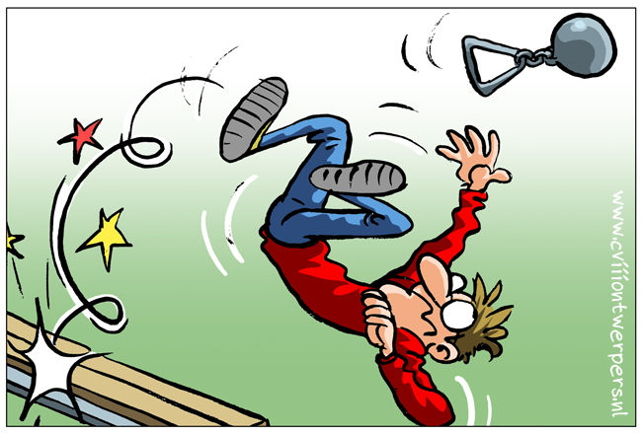](http://www.google.com/url?sa=i&rct=j&q=&esrc=s&frm=1&source=images&cd=&cad=rja&docid=PE_lGcO8oS26xM&tbnid=vqHnSpqWL_LtjM:&ved=0CAUQjRw&url=http://suvaal.blogspot.com/2011/03/onhandig.html&ei=bjguUZ_NO4qe0QWT3YCQBw&psig=AFQjCNEOY8K8wORLg_jtbPEQSR9kKWTyAw&ust=1362069969639232)

[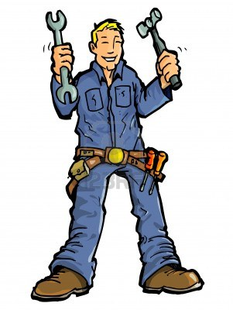](http://www.google.com/url?sa=i&rct=j&q=&esrc=s&frm=1&source=images&cd=&cad=rja&docid=tccPTYxUf-1IMM&tbnid=NEHH9mmu9ult8M:&ved=0CAUQjRw&url=http://nl.123rf.com/photo_10496217_cartoon-van-een-handige-man-met-al-zijn-tools-isolated-op-wit.html&ei=BTguUZCqFq2p0AXn7IDoCw&psig=AFQjCNHH_UUHjdtyIi5V2o8liRj9OmMyew&ust=1362069892430009)

**vaardig**

**onhandig**