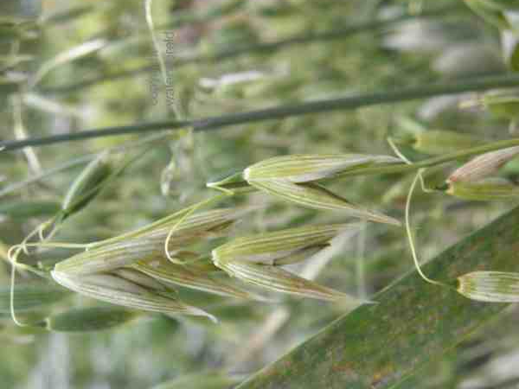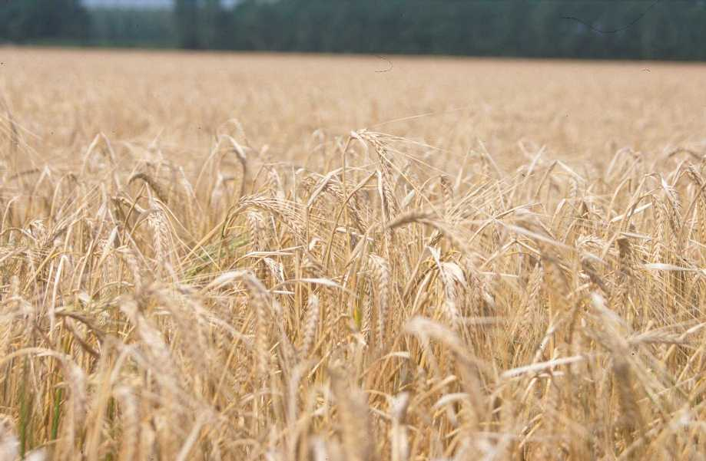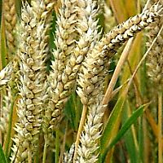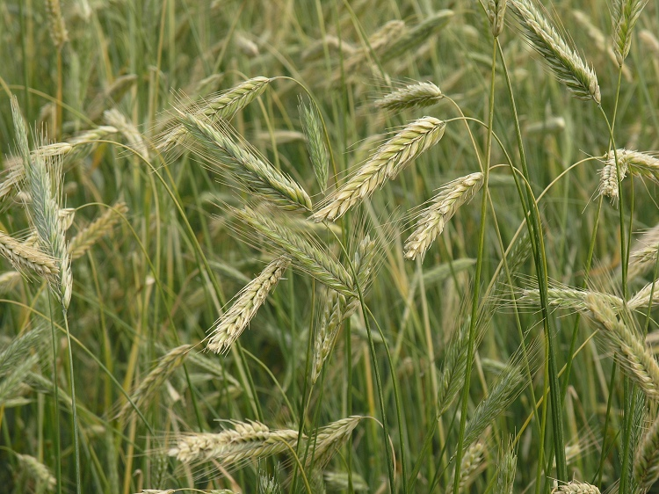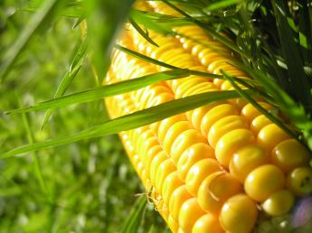[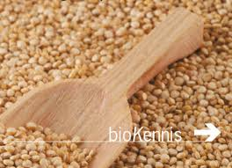](http://www.google.nl/imgres?q=GRANEN&hl=nl&biw=1024&bih=571&gbv=2&tbm=isch&tbnid=82h8Pwg2Ip2k_M:&imgrefurl=http://www.lei.wur.nl/NL/nieuwsagenda/archief/nieuws/2008/Granen_zonder_Gluten.htm&docid=aLXoycJO60eodM&imgurl=http://www.lei.wur.nl/NR/rdonlyres/5F164679-E05C-41CE-9E1E-9ECF2B890E6F/67570/granen1.gif&w=350&h=253&ei=HXmrT-e-Bsa-8AOaw53RBA&zoom=1&iact=hc&vpx=483&vpy=261&dur=4718&hovh=191&hovw=264&tx=200&ty=126&sig=101225824381766947501&page=1&tbnh=105&tbnw=142&start=0&ndsp=20&ved=1t:429,r:17,s:0,i:107)[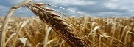](http://www.google.nl/imgres?q=TARWE&hl=nl&gbv=2&biw=1024&bih=571&tbm=isch&tbnid=vjrnfhXbm-7WcM:&imgrefurl=http://www.fairriqh.nl/foto/slides/046.%20Tarwe%20-%20FairriQh.nl.html&docid=BAAiD5BOFIqjyM&imgurl=http://www.fairriqh.nl/foto/slides/046.%2520Tarwe%2520-%2520FairriQh.nl.jpg&w=832&h=624&ei=PHirT43QPMjb8AP9l4DJBA&zoom=1&iact=hc&vpx=258&vpy=258&dur=7656&hovh=194&hovw=259&tx=187&ty=78&sig=101225824381766947501&page=2&tbnh=127&tbnw=158&start=9&ndsp=21&ved=1t:429,r:1,s:9,i:107)

**MAIS**

**GERST**

**HAVER**

**TARWE**

**ROGGE**

**GRAAN**