[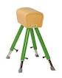](http://www.google.nl/imgres?imgurl=http://1.bp.blogspot.com/_4ekn5sjCQTw/TF2OERmUa1I/AAAAAAAAAXI/V-Y7DijBMdM/s1600/2020A.jpg&imgrefurl=http://basjeb.blogspot.com/2010/08/overwinning.html&usg=__L619Agsu8d0xzKG92SnXayM2euw=&h=214&w=170&sz=5&hl=nl&start=3&zoom=1&tbnid=ZqQ9x36ztFqQiM:&tbnh=106&tbnw=84&ei=W8nUTrLfF4-cOv-dtWk&prev=/search?q=de+bok+turnen&hl=nl&sa=N&gbv=2&tbm=isch&itbs=1)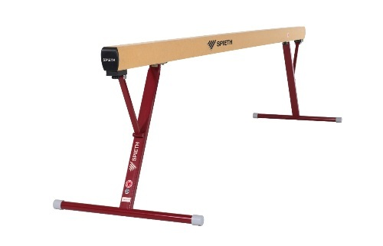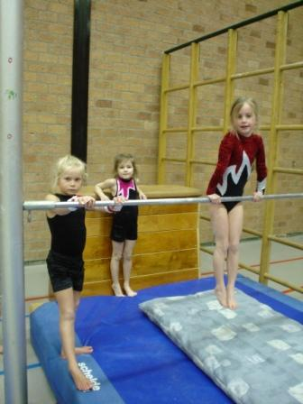

**de evenwichtsbalk**

**turnen**

**de rekstok**

**de bok**