**De Seizoenen**



**De herfst**

**De winter**

**De lente**

**De zomer**

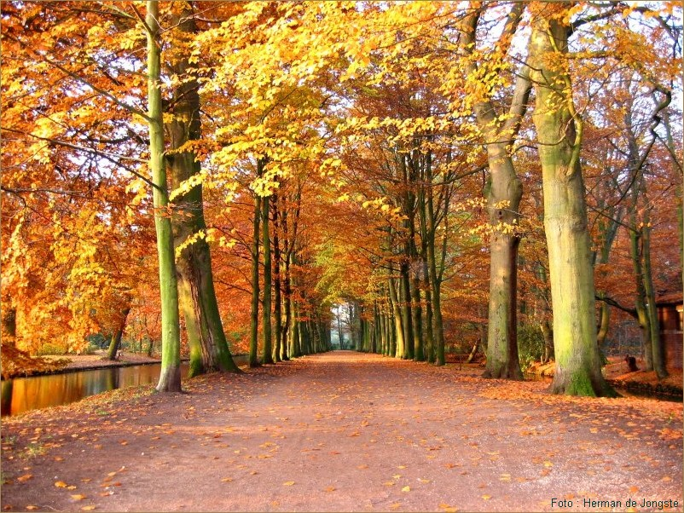

[](http://www.google.nl/imgres?imgurl=http://www.stichtingvlinders.nl/uploads/photos/zomer.jpg&imgrefurl=http://www.stichtingvlinders.nl/dagboek/antoine's-blog---zomer-in-passewaay/308&usg=__kxdx28Ohf6uyExMD9M-JpsEgNSU=&h=357&w=500&sz=94&hl=nl&start=2&zoom=1&itbs=1&tbnid=QREzEFeIiAqsgM:&tbnh=93&tbnw=130&prev=/images?q=zomer&hl=nl&gbv=2&tbs=isch:1&ei=SeJ5Te3HDIzpOcPb5eMG)[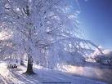](http://www.google.nl/imgres?imgurl=http://www.aberfeldycottages.co.uk/Images/river-tay-winter.bmp&imgrefurl=http://www.aberfeldycottages.co.uk/freebies.htm&usg=__xmnpozaaSVc6xbwb8-bPXs6Mi6o=&h=480&w=640&sz=302&hl=nl&start=1&zoom=1&itbs=1&tbnid=Y0oPq_Ha0cpN8M:&tbnh=103&tbnw=137&prev=/images?q=winter&hl=nl&gbv=2&tbs=isch:1&ei=5uF5Ta7GFdSr8QOzgb2XCw)

[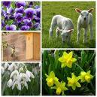](http://www.google.nl/imgres?imgurl=http://thelma.punt.nl/upload/lente1-1.jpg&imgrefurl=http://thelma.punt.nl/?r=1&id=455119&usg=__pKj2VqP0SU1H7fDr8CV1GOMCJvc=&h=480&w=480&sz=88&hl=nl&start=11&zoom=1&itbs=1&tbnid=alpJMhpDUbJpmM:&tbnh=129&tbnw=129&prev=/images?q=lente&hl=nl&gbv=2&tbs=isch:1&ei=EOJ5TZq_J8qdOrrIwOAG)