

[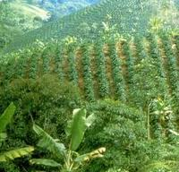](http://www.google.nl/imgres?q=koffieplantages&um=1&hl=nl&qscrl=1&nord=1&rlz=1T4SVEE_nl___NL412&biw=1920&bih=817&tbm=isch&tbnid=dBmMUv5ep4-gmM:&imgrefurl=http://koffie.met-passie.nl/koffie/koffieboon-koffiebonen/koffieplantages.html&docid=aGO6VQYqDuDb_M&imgurl=http://koffie.met-passie.nl/typo3temp/pics/f1fe9d3279.jpg&w=250&h=241&ei=uw7QTuHAFYPrObf73I0P&zoom=1)

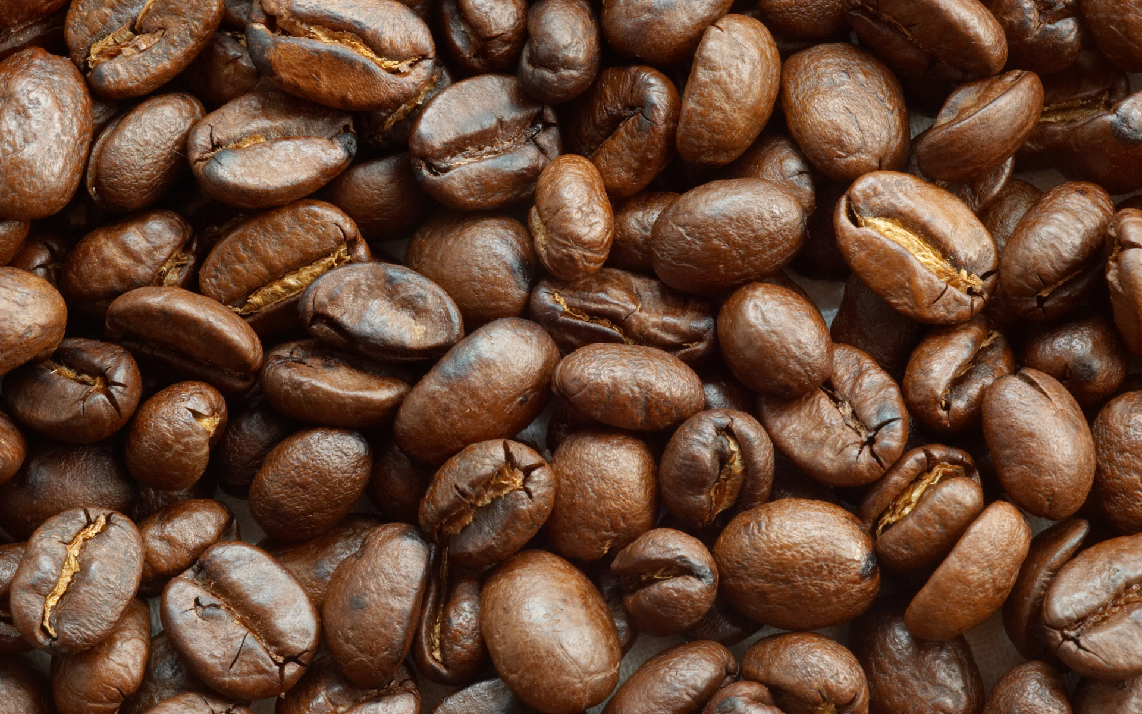

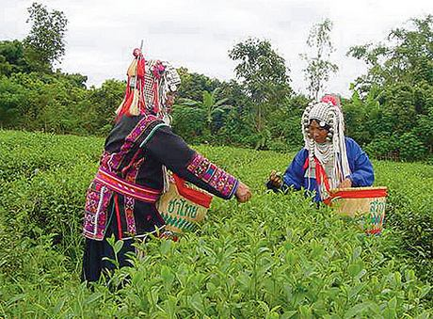

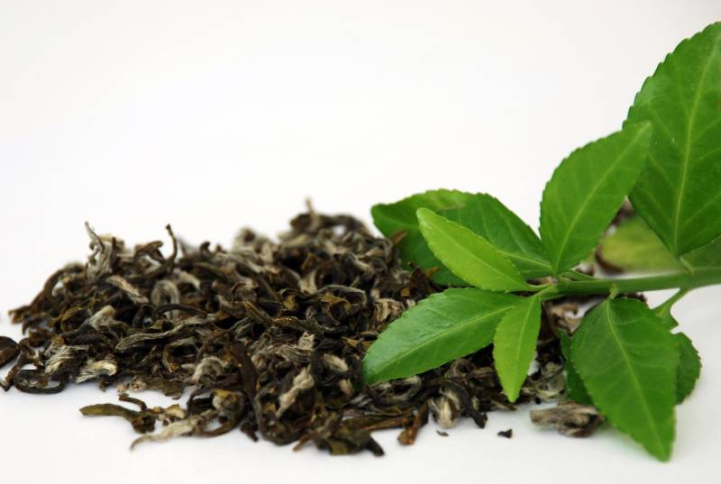

[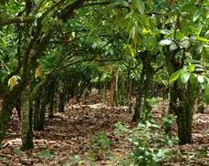](http://www.google.nl/imgres?q=cacaoplantage&um=1&hl=nl&qscrl=1&nord=1&rlz=1T4SVEE_nl___NL412&biw=1920&bih=817&tbm=isch&tbnid=Zf32G54_zNbADM:&imgrefurl=http://www.chocohlala.be/maken%20vd%20chocolade.html&docid=ftFLJtoo9Q4b0M&imgurl=http://www.chocohlala.be/chocolade%2520images/cacaoplantage.jpg&w=287&h=228&ei=6xDQTvbPD4voOb2v1Z8P&zoom=1)

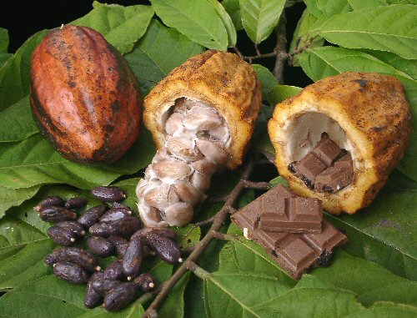

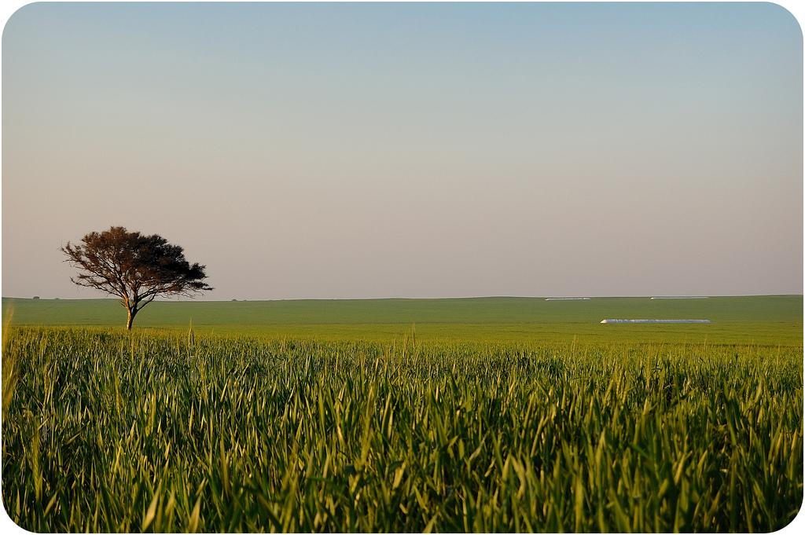

[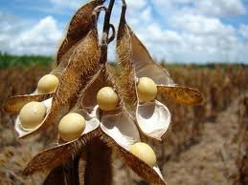](http://www.google.nl/imgres?q=soja&um=1&hl=nl&qscrl=1&nord=1&rlz=1T4SVEE_nl___NL412&biw=1920&bih=817&tbm=isch&tbnid=oeqoVHC62BagEM:&imgrefurl=http://gezondheid.blog.nl/actualiteiten/2009/04/30/soja-gezond-of-juist-niet&docid=5O2mTCO3TWQtcM&imgurl=http://farm3.static.flickr.com/2095/2286217135_0799bc72f9.jpg&w=500&h=375&ei=hBDQTqHCFMntOav0yKkP&zoom=1)

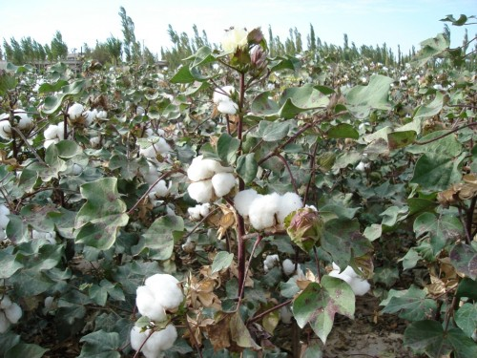

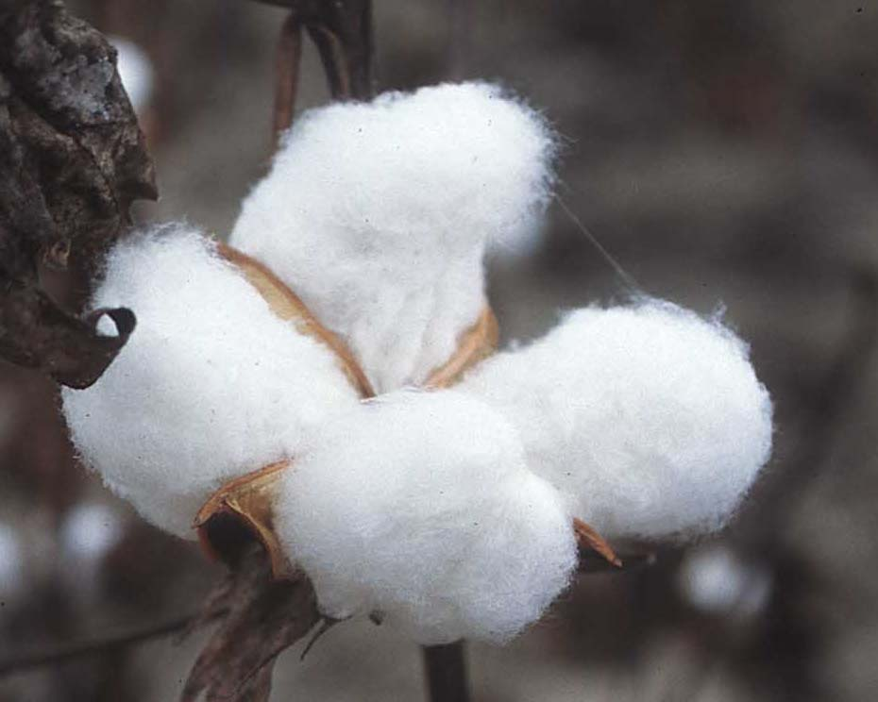

**soja**

**cacao**

**koffie**

**thee**

**katoen**

**de plantage**