[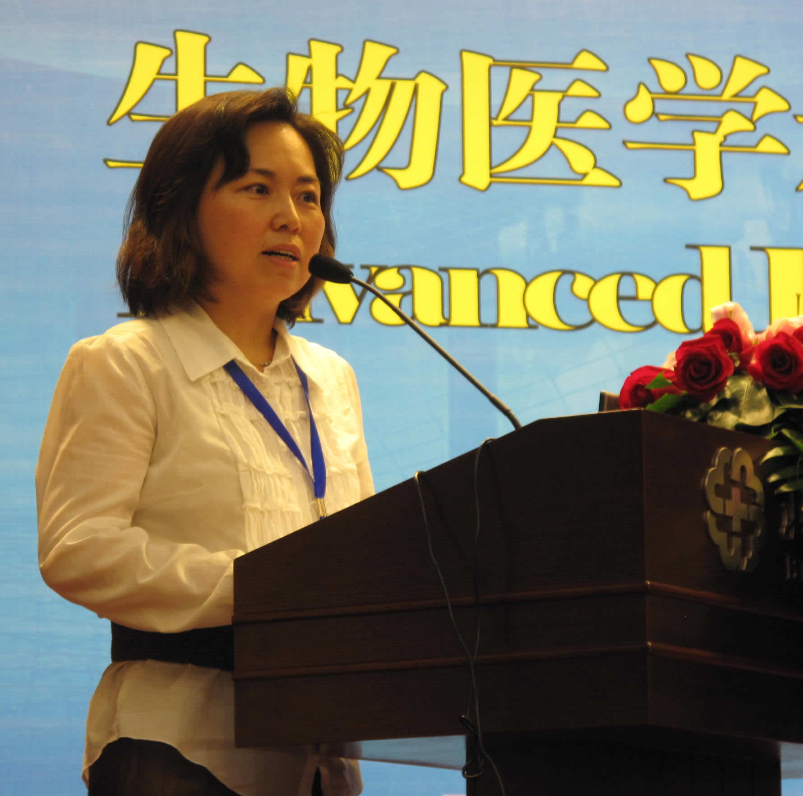](http://www.google.com/url?sa=i&rct=j&q=&esrc=s&frm=1&source=images&cd=&cad=rja&docid=68qvVkkNqJmkCM&tbnid=n7zOgZjpxXENpM:&ved=0CAUQjRw&url=http%3A%2F%2Fwww.kuleuven.be%2Fradiology%2Feapcobir%2Findex.php%3Flocation%3Devents&ei=lTEuUfDhI-eY1AWOn4CoCg&bvm=bv.42965579,d.d2k&psig=AFQjCNGk_ziUx_IBxC4kvqD_VmwQB_2u3w&ust=1362068084188668)

[](http://www.google.com/url?sa=i&rct=j&q=&esrc=s&frm=1&source=images&cd=&cad=rja&docid=Qvr2CHuKcSm_UM&tbnid=mI18jM__wrPoTM:&ved=0CAUQjRw&url=http://www.she.be/nl/jij/aid1119489/top-5-wat-we-te-allen-tijde-proberen-verzwijgen.aspx&ei=7jEuUendLqua0QWenYAQ&bvm=bv.42965579,d.d2k&psig=AFQjCNESztk35YIuUJ3gyh2JStdk6WgX_w&ust=1362068315339709)

**Bekendmaken**

**verzwijgen**