[](http://www.google.com/url?sa=i&rct=j&q=&esrc=s&frm=1&source=images&cd=&cad=rja&docid=C0Z89lmR0zL8EM&tbnid=4LBEAGzPeGmxFM:&ved=0CAUQjRw&url=http://www.onderhoudsbedrijvenindenhaag.nl/&ei=O5kvUYvcAcup0AWdzoDIBw&bvm=bv.43148975,d.d2k&psig=AFQjCNFcNXe6eoyX7znZBqmOPISB6FJDxQ&ust=1362160309700685)[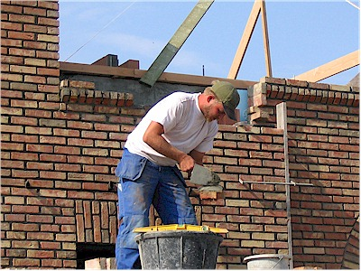](http://www.google.com/url?sa=i&rct=j&q=&esrc=s&frm=1&source=images&cd=&cad=rja&docid=cgqlmArTpGJ4IM&tbnid=oboHPOD_ztmJoM:&ved=0CAUQjRw&url=http://www.zadkine-techniek.nl/bhs/index.php?pg=31&ei=hZgvUYyCKcWk0AWAj4HIDQ&bvm=bv.43148975,d.d2k&psig=AFQjCNHJQCdMEC3AgO3RYvkK1cNe893xdw&ust=1362160068825650)[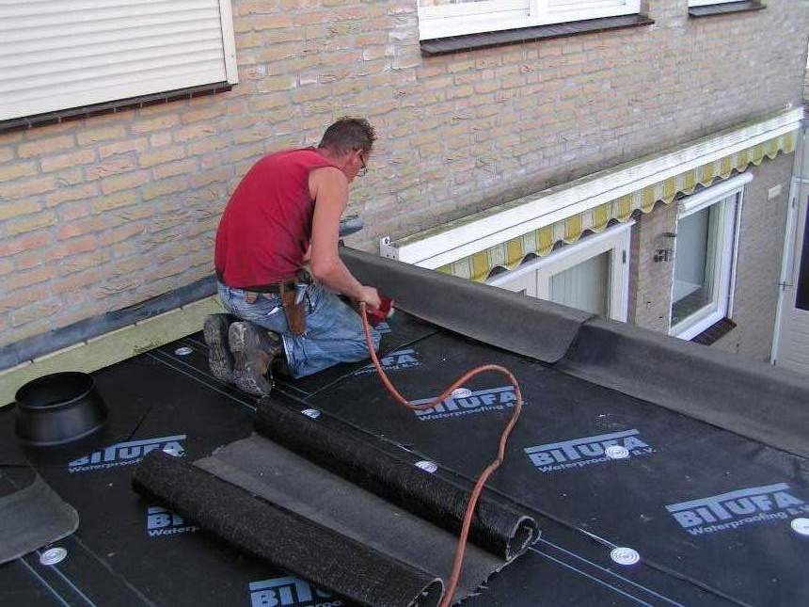](http://www.google.com/url?sa=i&rct=j&q=&esrc=s&frm=1&source=images&cd=&cad=rja&docid=FVNlONUfh7UjwM&tbnid=HBC6QcYC2Am5WM:&ved=0CAUQjRw&url=http://dakbedekking.maakjestart.nl/&ei=UpcvUY_oK4WH0AW04oGIBA&bvm=bv.43148975,d.d2k&psig=AFQjCNFBVGg67s-FLmdzDxsQLdgtNVEowA&ust=1362159812511053)[](http://www.google.com/url?sa=i&rct=j&q=&esrc=s&frm=1&source=images&cd=&cad=rja&docid=TguX8FI7J--tLM&tbnid=6jmMZdMNId2VjM:&ved=0CAUQjRw&url=http://www.bouwschool.be/cursusaanbod/algemeen-aannemer/&ei=5JYvUazhL-TY0QW77oDIAg&bvm=bv.43148975,d.d2k&psig=AFQjCNG6sWhVuemVU5queJql9i0Dt97Ieg&ust=1362159708244411)

**De huisschilder**

**De metselaar**

**De dakdekker**

[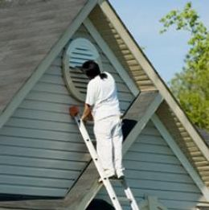](http://www.google.com/url?sa=i&rct=j&q=&esrc=s&frm=1&source=images&cd=&cad=rja&docid=gHixRSep1X_C6M&tbnid=StR4UcokLqLXAM:&ved=0CAUQjRw&url=http://groningen.schildersbedrijf-nl.nl/&ei=o5kvUZmOH8O80QX_wYG4Aw&bvm=bv.43148975,d.d2k&psig=AFQjCNEIIhdaegbySnZHzNQ-kbD9OF44uQ&ust=1362160408120600)

**De Aannemer**

**De timmerman**