[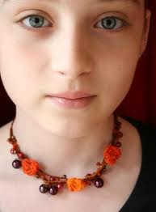](http://www.google.nl/imgres?q=halsketting&start=240&um=1&hl=nl&sa=N&rlz=1T4ACAW_nlNL316NL319&biw=1280&bih=574&tbm=isch&tbnid=oo-Xwm67iWnTnM:&imgrefurl=http://www.amigurumiswebshop.nl/index.php%3Faction%3Darticle%26group_id%3D12%26aid%3D74%26lang%3DNL&docid=MyXhZrynfWcSgM&imgurl=http://www.amigurumiswebshop.nl/data/mediablocks/mb_0_74_ms1.JPG&w=330&h=448&ei=NKXrTvLTBse6-AbQ1_2zCQ&zoom=1&chk=sbg)

**De sieraden**

**Oorbellen**

**Een ketting**

**Een ring**