[](http://www.google.com/url?sa=i&rct=j&q=ingeving&source=images&cd=&cad=rja&docid=p6cS2LC9bf9pPM&tbnid=H-yeLDU9hIsxdM:&ved=0CAUQjRw&url=http://kidstalkblog.wordpress.com/category/zelfvertrouwen/&ei=7j9wUfmOD-mI0AXu0oEg&bvm=bv.45373924,d.d2k&psig=AFQjCNEgjfhvuW-dxyZBq4XTK1vypK1A-A&ust=1366397272681288)[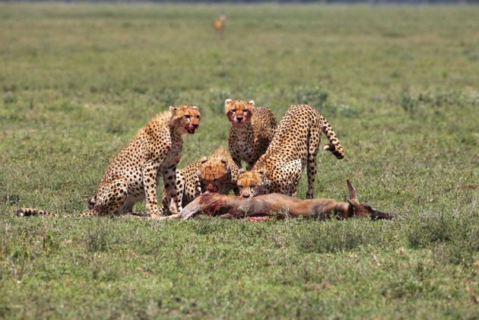](http://www.google.com/url?sa=i&rct=j&q=instinct&source=images&cd=&cad=rja&docid=eHd66gzfAX0OPM&tbnid=XAXDGmMhym03UM:&ved=0CAUQjRw&url=http://tv.yahoo.com/photos/big-cat-week-cheetah-fatal-instinct-slideshow/&ei=FD9wUZfqMsXK0AWK2oH4BA&bvm=bv.45373924,d.d2k&psig=AFQjCNFj-W2AqdYa6dGFqE3-rOdY06yObg&ust=1366397020621477)

**synoniemen**

**Het instinct**

**De ingeving**

**De feeling**

**De intuïtie**