**gebroken licht**

[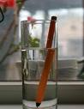](http://www.google.nl/imgres?imgurl=http://www.duivensites.nl/content/inversie-glas-water-potlood.jpg&imgrefurl=http://www.duivensites.nl/default.asp?Title=Ori%EBntatie&ContentId=1877&LanguageId=31&NewsId=53527&usg=__PnLwkYkuFPoLoDFJr-0dMz4gL1U=&h=443&w=341&sz=17&hl=nl&start=13&zoom=1&itbs=1&tbnid=opkCQ40HLUEBnM:&tbnh=127&tbnw=98&prev=/images?q=gebroken+licht+in+een+glas+water&hl=nl&sa=G&gbv=2&tbm=isch&ei=dlnfTZ7wDYWf-Qb1y93EDQ)

**infrarood**

[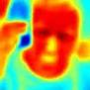](http://www.google.nl/imgres?imgurl=http://www.ster.kuleuven.be/outreach/infrarood.jpg&imgrefurl=http://www.ster.kuleuven.be/outreach/index_nl.html&usg=__2OHNw-d1ZFnqxTRpETFVpu6R5R8=&h=128&w=128&sz=3&hl=nl&start=4&zoom=1&itbs=1&tbnid=ngB3b6uhnW3eoM:&tbnh=91&tbnw=91&prev=/search?q=infrarood+kijker&hl=nl&sa=G&biw=1003&bih=592&gbv=2&tbm=isch&ei=z1ffTeyEKsPo-gbamdjDDQ)

**uv-licht**

[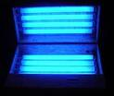](http://www.google.nl/imgres?imgurl=http://topnews.in/health/files/ultraviolet_light.jpg&imgrefurl=http://www.simsforum.nl/forum/view/id/30771/d/uv-licht&usg=__g1Zc2hMKAAWFdGrP_i2YzEOZ57A=&h=326&w=384&sz=15&hl=nl&start=3&zoom=1&itbs=1&tbnid=kzJwJKc8WIkdoM:&tbnh=104&tbnw=123&prev=/search?q=uv+licht&hl=nl&biw=1003&bih=592&gbv=2&tbm=isch&ei=bVffTcXQGtGF-wa1ptjEDQ)

**absorberen**

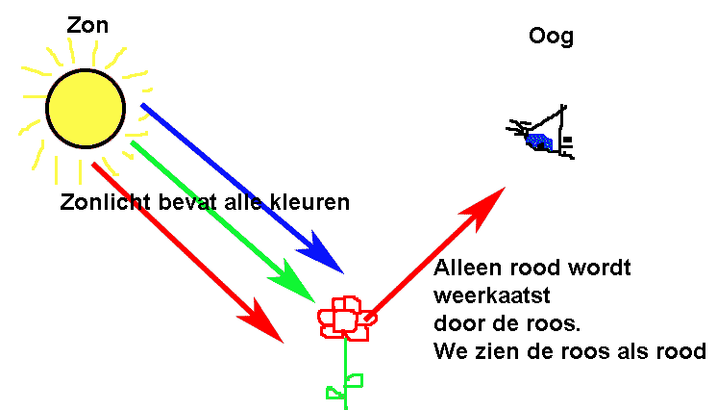

**onzichtbaar licht**

**(röntgenstralen)**

[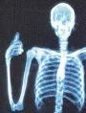](http://www.google.nl/imgres?imgurl=http://www.viecuri.nl/viecuri_C01/UploadData/images/4/0/Lezen_wat_is_het/2008_MM_Rontgenfoto.jpg&imgrefurl=http://www.viecuri.nl/viecuri_C01/Default.asp?CustID=667&ComID=4&ModID=845&ItemID=6068&SessionID=-1&bottest=&usg=__z-lahPsnpeZMXEBJkf2y_Xa_NWE=&h=323&w=245&sz=18&hl=nl&start=2&zoom=1&itbs=1&tbnid=qt1XHPOzcd1-rM:&tbnh=118&tbnw=90&prev=/search?q=rontgenfoto&hl=nl&sa=G&biw=1003&bih=592&gbv=2&tbm=isch&ei=OFffTa6vHsyc-wan_JHEDQ)

**spectrum**

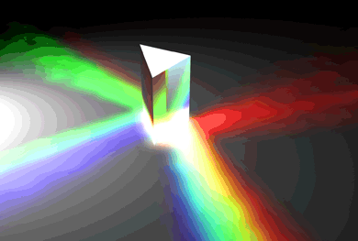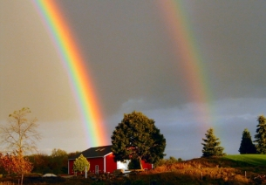

licht en kleur